Dear Parents and Students,
I Have Arranged the Following Schedule of Available Time to Accommodate Recent Requests for Individual Private Lessons at the School. Interested Students Should Complete the Application Below and Return It to Master Park. Proceeds From These Private Lesson Program Will Help Fund School Improvement Projects.
Thank You for Your Interest in This Program. (Each private lesson will count as 3 days attendance)

EACH LESSON WILL BE 45 MINUTE
Currently Enrolled CHONG HYO Student: $50.00
Non- Student: $60.00
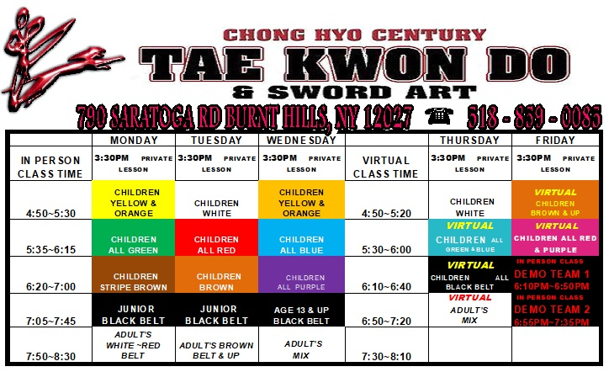

(Keep the top portion)
-------------------------------------------------------------------------------------------------------------------------------------------------------------
(Turn in the bottom portion with payment)
APPLICATION

NAME_________________________RANK________ DATE OFBIRTH___/___/___

ADDRESS__________________________________HOME PHONE#______________

LEARNING OBJECTIVES? FORM( ), SPARRING( ), BREAKING( ),
SELF - DEFENCE( ), ADVANCE KICK( ), FOR TEST( ), FOR CHAMPIONSHP( ), BACK FLIP ( )
HAE DONG KUM DO <KOREAN TRADITIONAL SWORD>( ),
SCHEDULE CHOICE (DATE, TIME) I_____________, II_____________,III,____________
PARENT / GUARDIAN SIGNATURE: _________________________DATE_________

